DEFECT REPORT

MANUAL TESTING PROJECT

AKASH.E

DEFECT ID  **: 001**

TEST ENVIRONMENT **:** OS (WINDOWS 11)

BROWSER (I.E.)

VERSION OF BROWSER (10)

DEFECT DESCRIPTION: DROP DOWN IS NOT DISPLAYED FOR

SHOP BY CATEGORY IN IE (10)

DETAILED DESCRIPTION **:**

1. Open the browser enter the URL( [www.sastasundar.com](http://www.sastasundar.com) ), click on go button.
2. Home page of sastasundar app will be displayed.
3. Place a cursor on shop by category.

EXPECTED RESULT  **:** DROP DOWN SHOULD BE DISPLAYED.

ACTUAL RESULT **:** DROP DOWN IS NOT DISPLAYED.

SCREEN SHOT:

1.INTERNET EXPLORER:

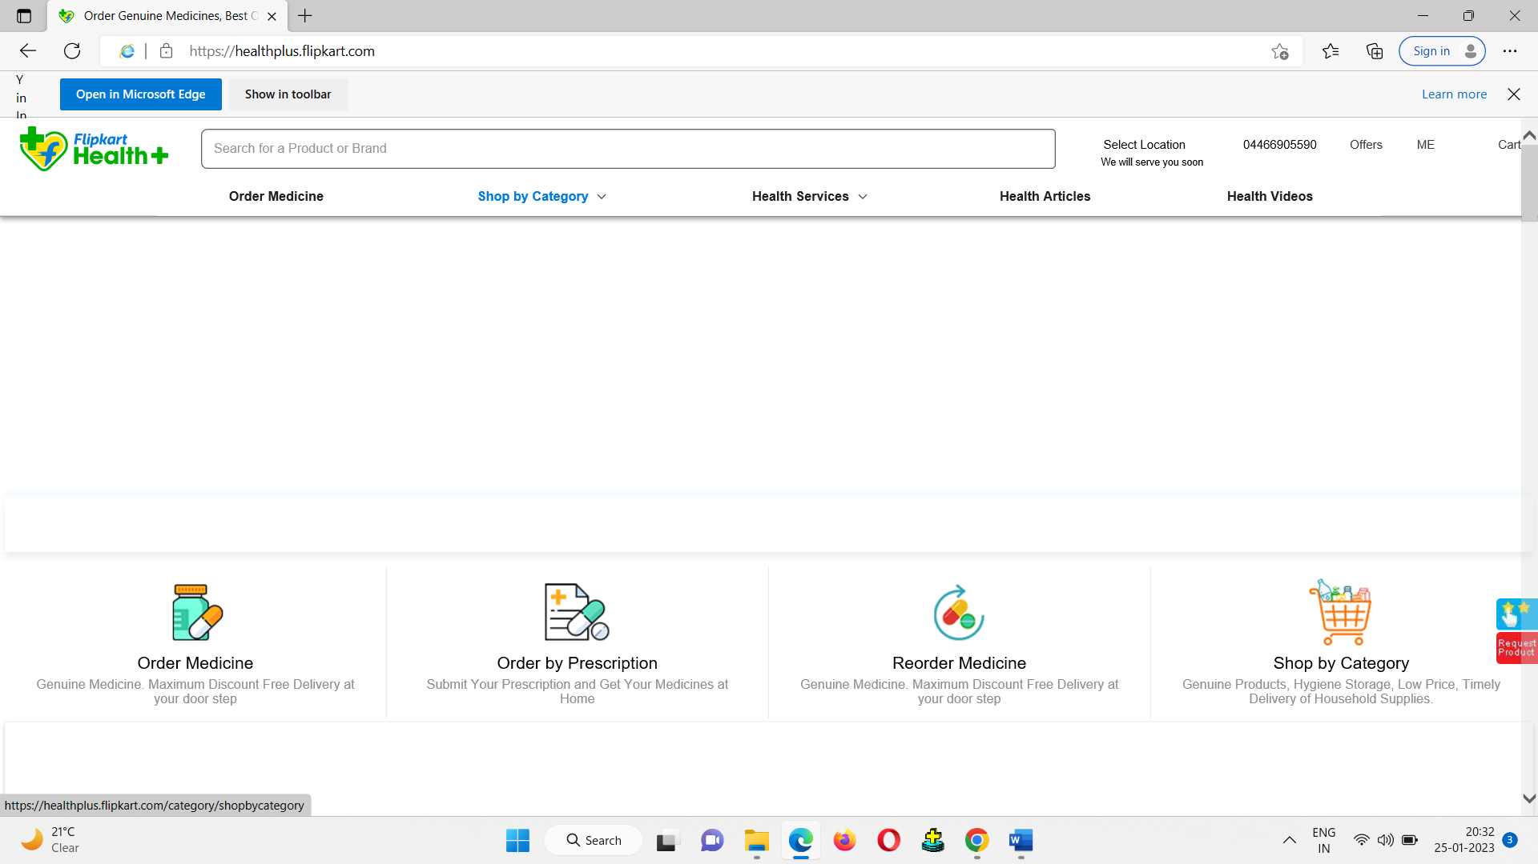

2.CHORME

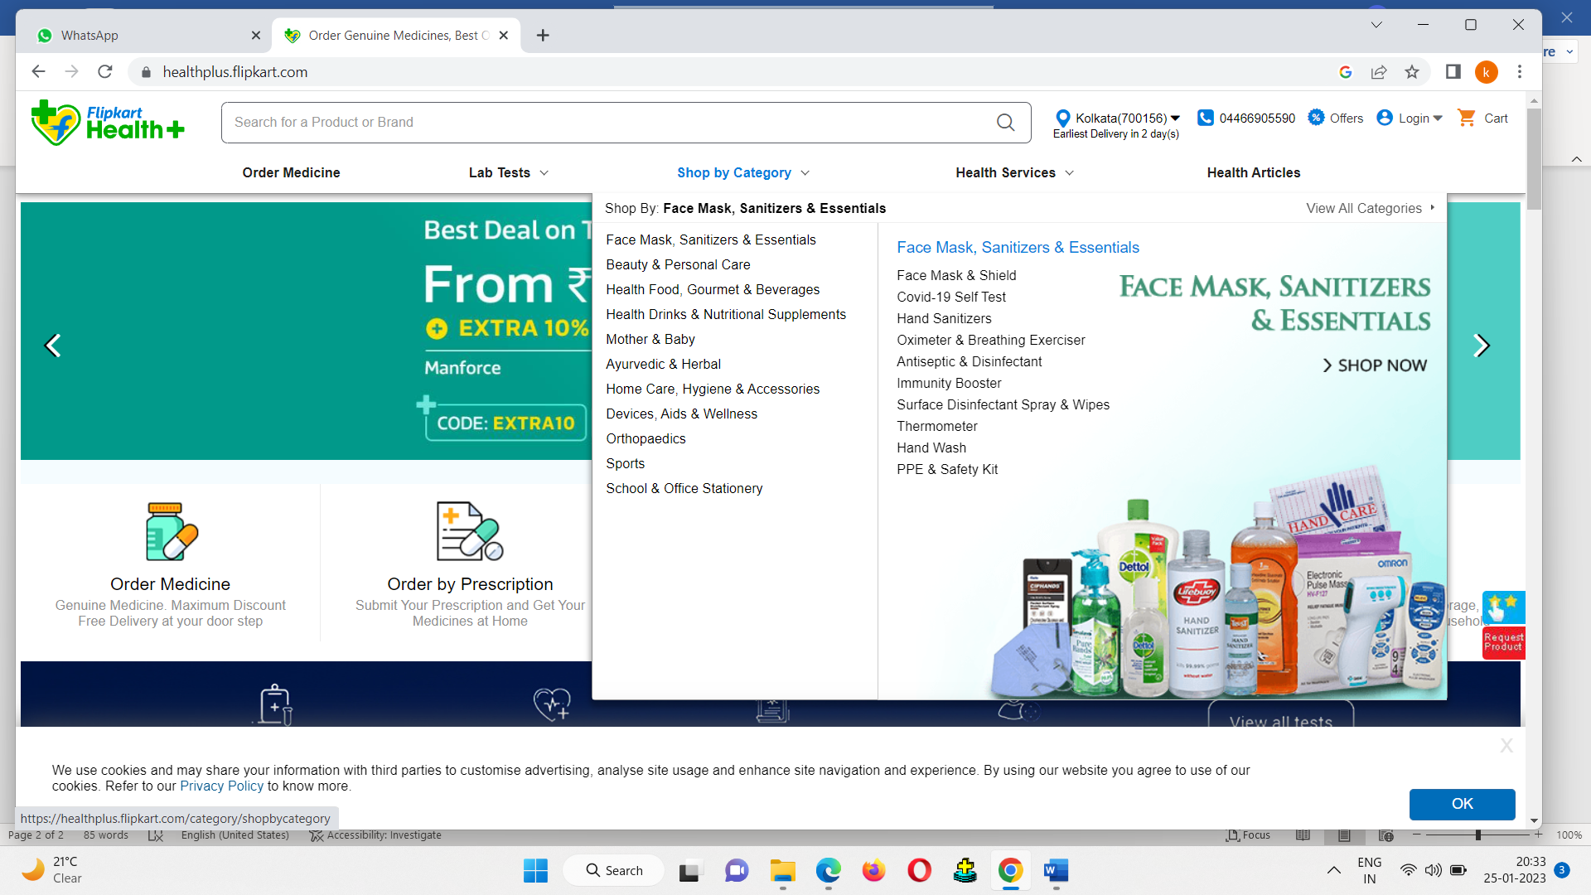

DEFECT ID  **: 002**

TEST ENVIRONMENT **:** OS (WINDOWS 11)

BROWSER (I.E.)

VERSION OF BROWSER (10)

DEFECT DESCRIPTION: DROP DOWN IS NOT DISPLAYED FOR

HEALTH SERVICES IN IE (10)

DETAILED DESCRIPTION **:**

1. Open the browser enter the URL( [www.sastasundar.com](http://www.sastasundar.com) ), click on go button.
2. Home page of sastasundar app will be displayed.
3. Place a cursor on health services.

EXPECTED RESULT  **:** DROP DOWN SHOULD BE DISPLAYED.

ACTUAL RESULT **:** DROP DOWN IS NOT DISPLAYED.

SCREEN SHOT:

1.INTERNET EXPLORER:

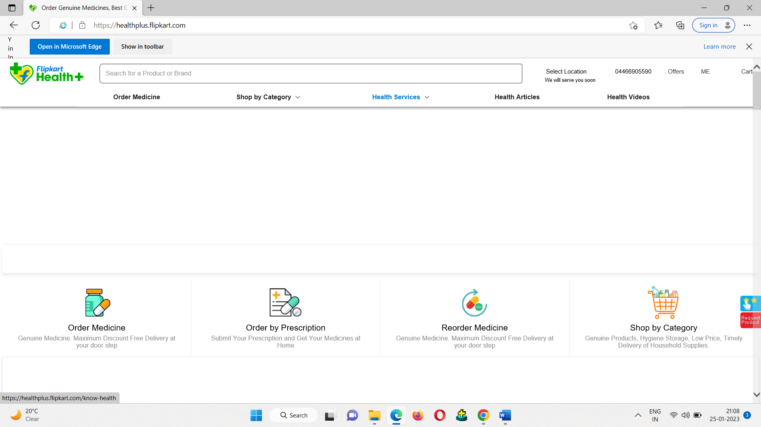

2.CHORME:

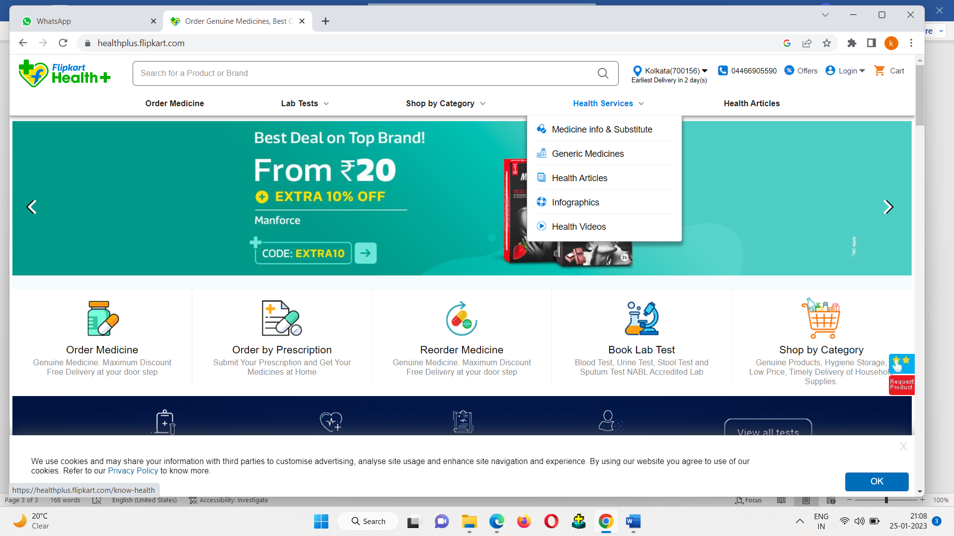

DEFECT ID  **: 003**

TEST ENVIRONMENT **:** OS (WINDOWS 11)

BROWSER (I.E.)

VERSION OF BROWSER (10)

DEFECT DESCRIPTION: SEARCH BAR IS NOT WORKING PROPERLY

IN IE (10)

DETAILED DESCRIPTION **:**

1. Open the browser enter the URL( [www.sastasundar.com](http://www.sastasundar.com) ), click on go button.
2. Home page of sastasundar app will be displayed.
3. Place a cursor on search bar.
4. Search for medicine

EXPECTED RESULT  **:** MEDICINE PAGE SHOULD BE DISPLAYED.

ACTUAL RESULT **:** MEDICINE PAGE IS NOT DISPLAYED.

SCREEN SHOT:

1.INTERNET EXPLORER:

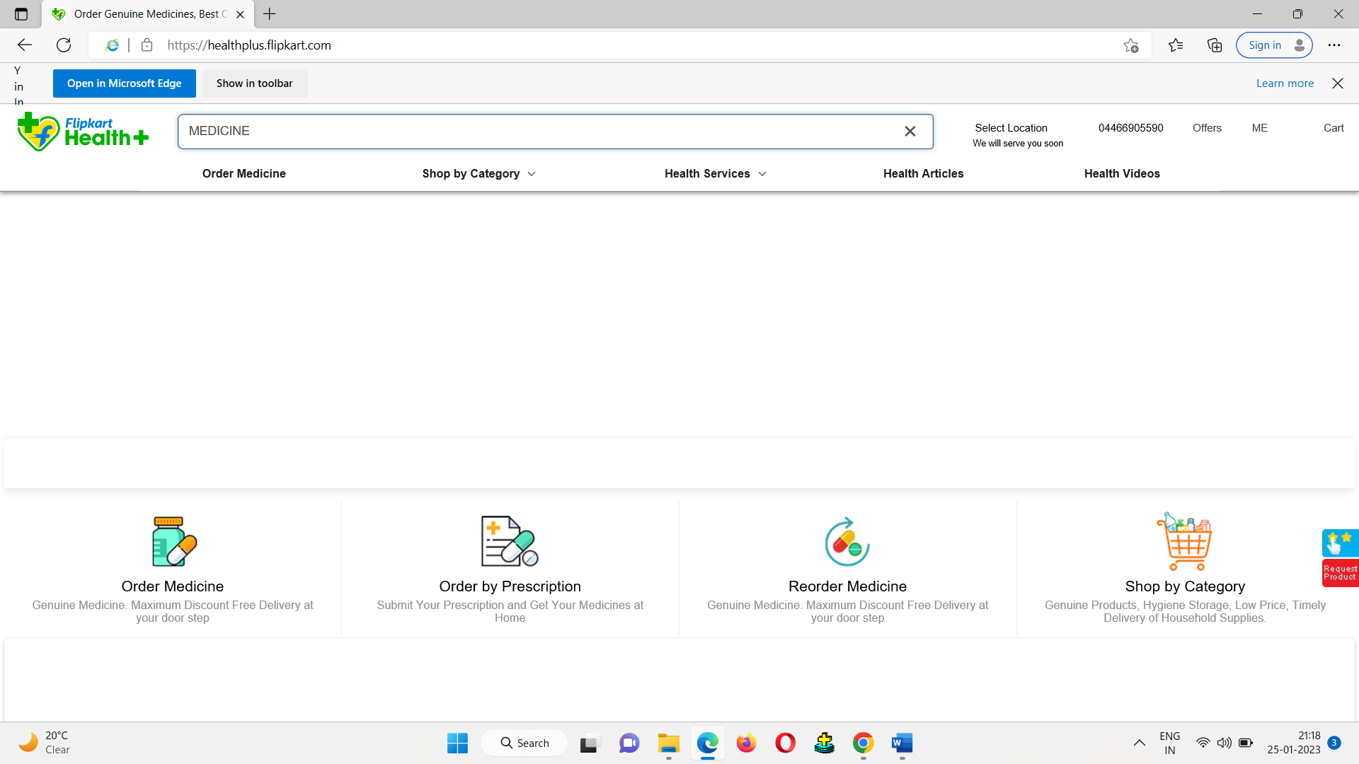

2.CHORME:

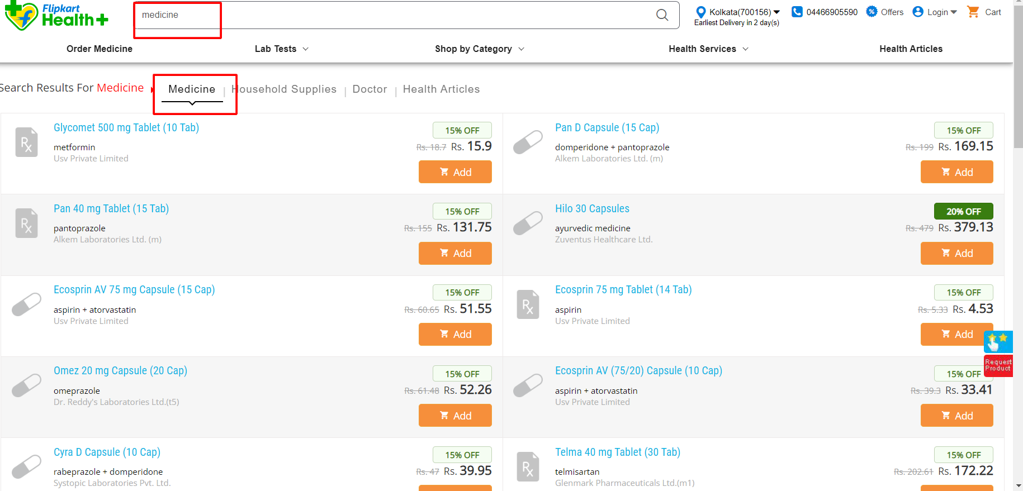

DEFECT ID  **: 004**

TEST ENVIRONMENT **:** OS (WINDOWS 11)

BROWSER (I.E.)

VERSION OF BROWSER (10)

DEFECT DESCRIPTION: IN SEARCH BAR SUGGESTION LIST IS NOT WORKING PROPERLY IN IE (10)

DETAILED DESCRIPTION **:**

1. Open the browser enter the URL( [www.sastasundar.com](http://www.sastasundar.com) ), click on go button.
2. Home page of sastasundar app will be displayed.
3. Place a cursor on search bar.
4. Search for medicine

EXPECTED RESULT **:** SUGGESTION LIST SHOULD BE DISPLAYED.

ACTUAL RESULT **:** SUGGESTION LIST IS NOT DISPLAYED.

SCREEN SHOT:

1.INTERNET EXPLORER:

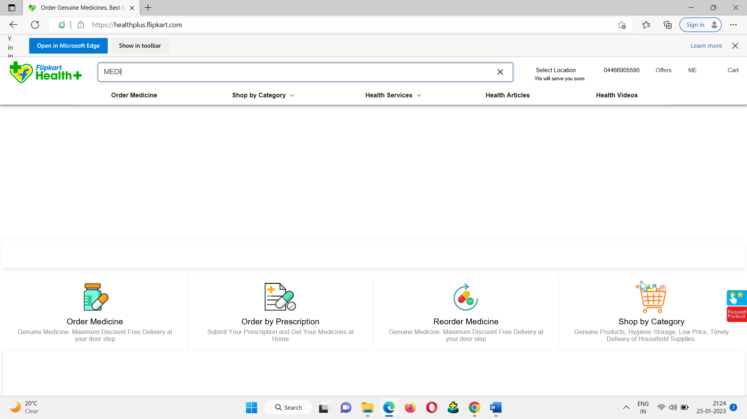

2.CHORME:

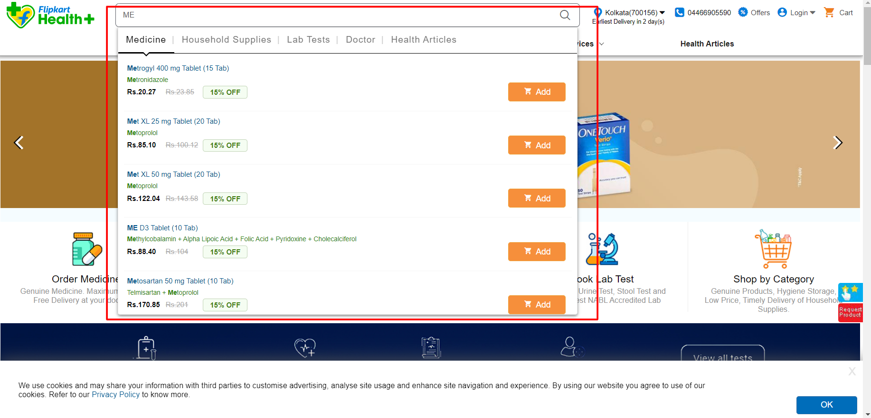

DEFECT ID  **: 005**

TEST ENVIRONMENT **:** OS (WINDOWS 11)

BROWSER (I.E.)

VERSION OF BROWSER (10)

DEFECT DESCRIPTION: IN SEARCH BAR SEARCH ICON IS NOT VISIBLE IN IE (10)

DETAILED DESCRIPTION **:**

1. Open the browser enter the URL( [www.sastasundar.com](http://www.sastasundar.com) ), click on go button.
2. Home page of sastasundar app will be displayed.
3. Place a cursor on search bar.

EXPECTED RESULT **:** SEARCH ICON SHOULD BE DISPLAYED.

ACTUAL RESULT **:** SEARCH ICON IS NOT DISPLAYED.

SCREEN SHOT:

1.INTERNET EXPLORER:

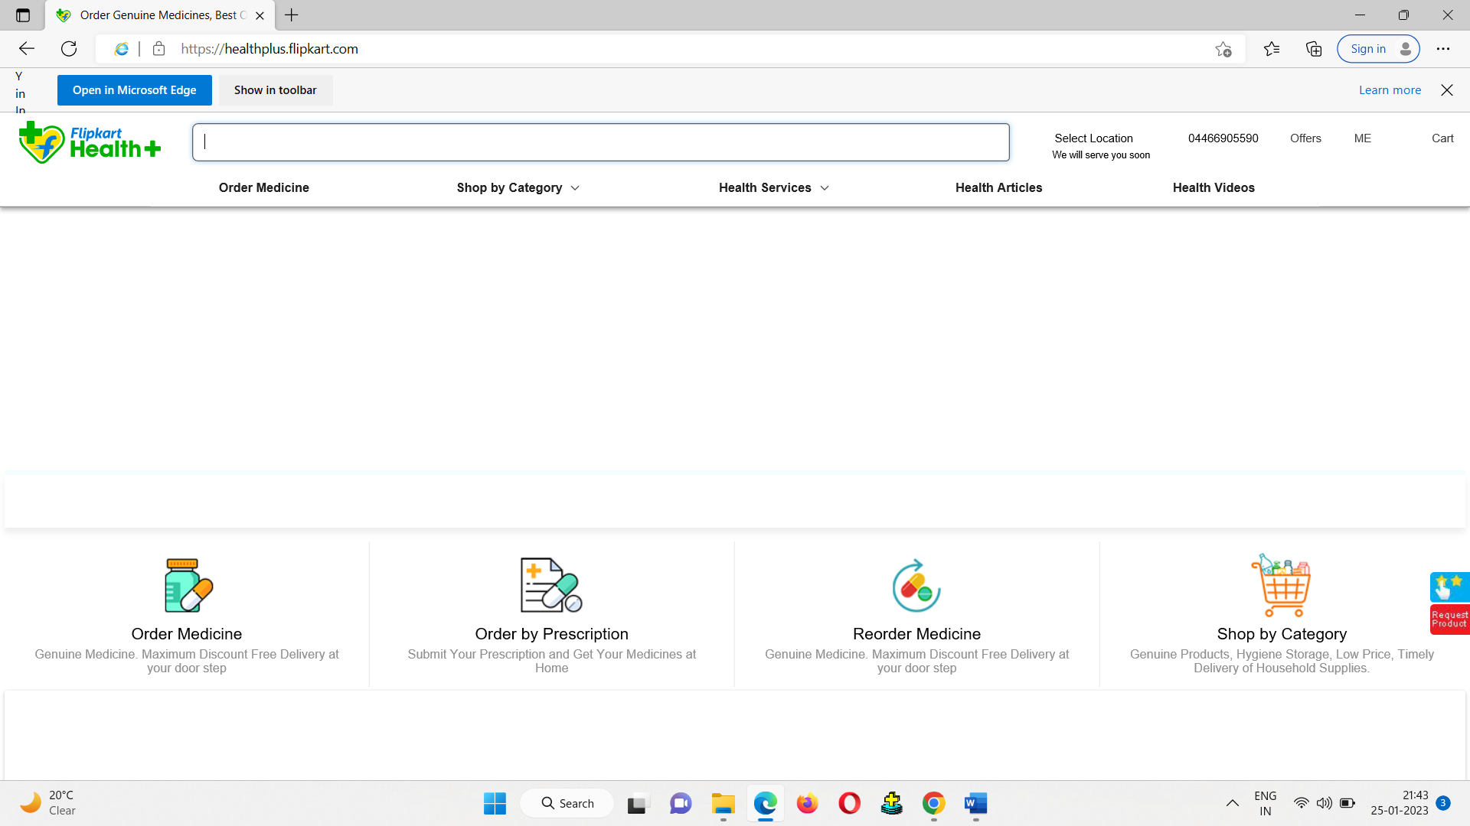

2.CHROME:

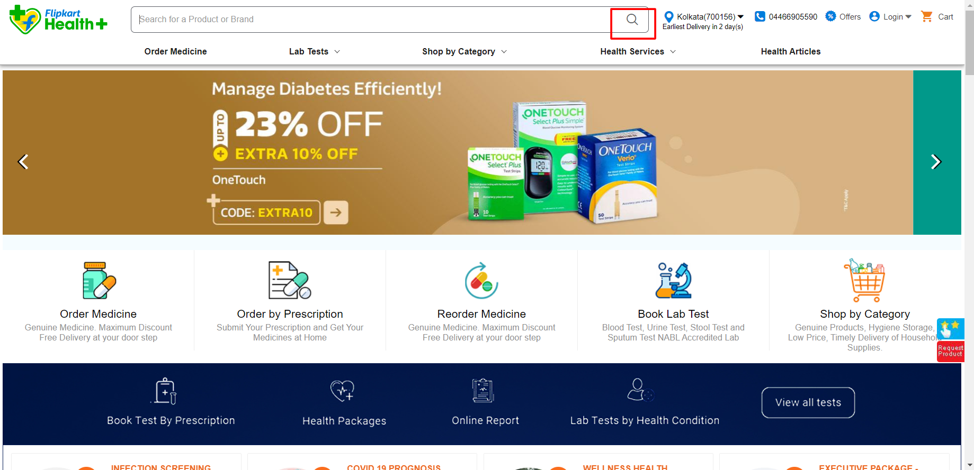

DEFECT ID  **: 006**

TEST ENVIRONMENT **:** OS (WINDOWS 11)

BROWSER (I.E.)

VERSION OF BROWSER (10)

DEFECT DESCRIPTION: ICONS OF LOCATION, PHONE, OFFERS, LOGIN AND CART IS NOT VISIBLE IN IE (10)

DETAILED DESCRIPTION **:**

1. Open the browser enter the URL( [www.sastasundar.com](http://www.sastasundar.com) ), click on go button.
2. Home page of sastasundar app will be displayed.

EXPECTED RESULT **:** ICONS SHOULD BE DISPLAYED.

ACTUAL RESULT **:** ICONS IS NOT DISPLAYED.

SCREEN SHOT:

1.INTERNET EXPLORER:

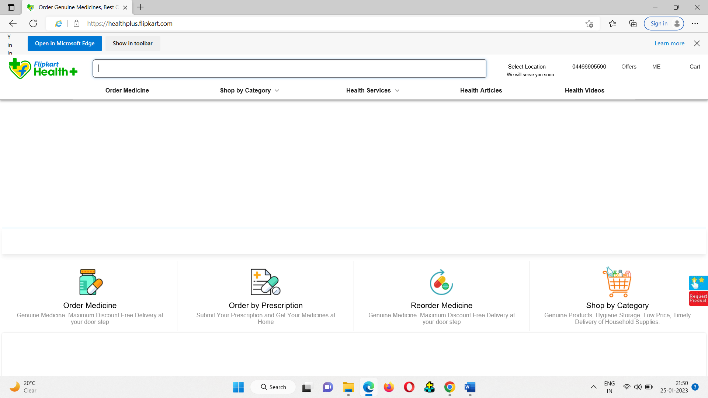

2.CHORME:

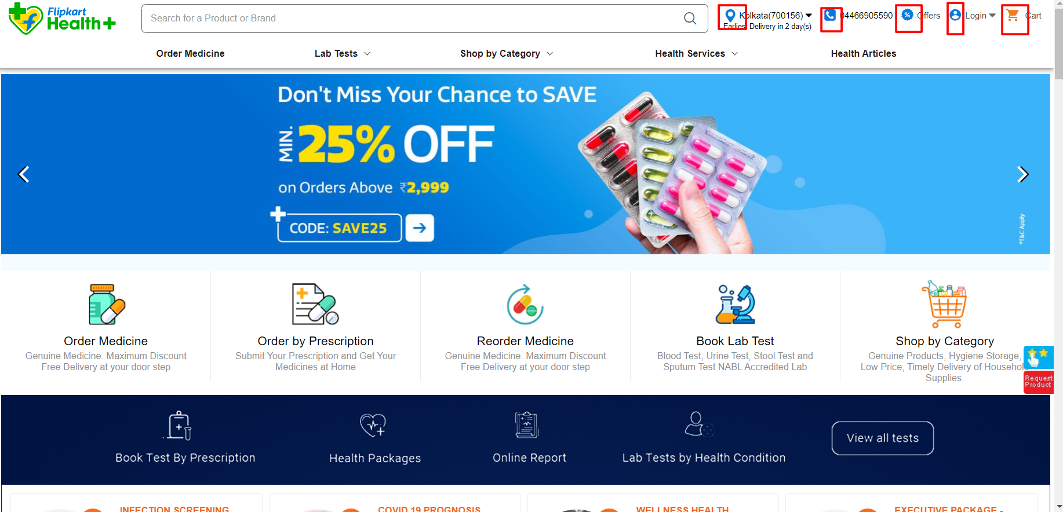

DEFECT ID  **: 007**

TEST ENVIRONMENT **:** OS (WINDOWS 11)

BROWSER (I.E.)

VERSION OF BROWSER (10)

DEFECT DESCRIPTION: CART PAGE LINK NOT WORKING IN IE (10)

DETAILED DESCRIPTION **:**

1. Open the browser enter the URL( [www.sastasundar.com](http://www.sastasundar.com) ), click on go button.
2. Home page of sastasundar app will be displayed.
3. Click on the cart icon.

EXPECTED RESULT **:** CART PAGE SHOULD BE DISPLAYED.

ACTUAL RESULT **:** CART PAGE IS EMPTY.

SCREEN SHOT:

1.INTERNET EXPLORER:

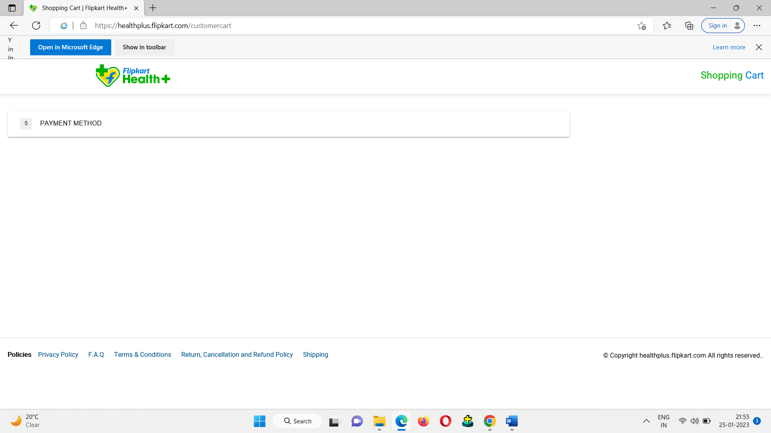

2.CHORME:

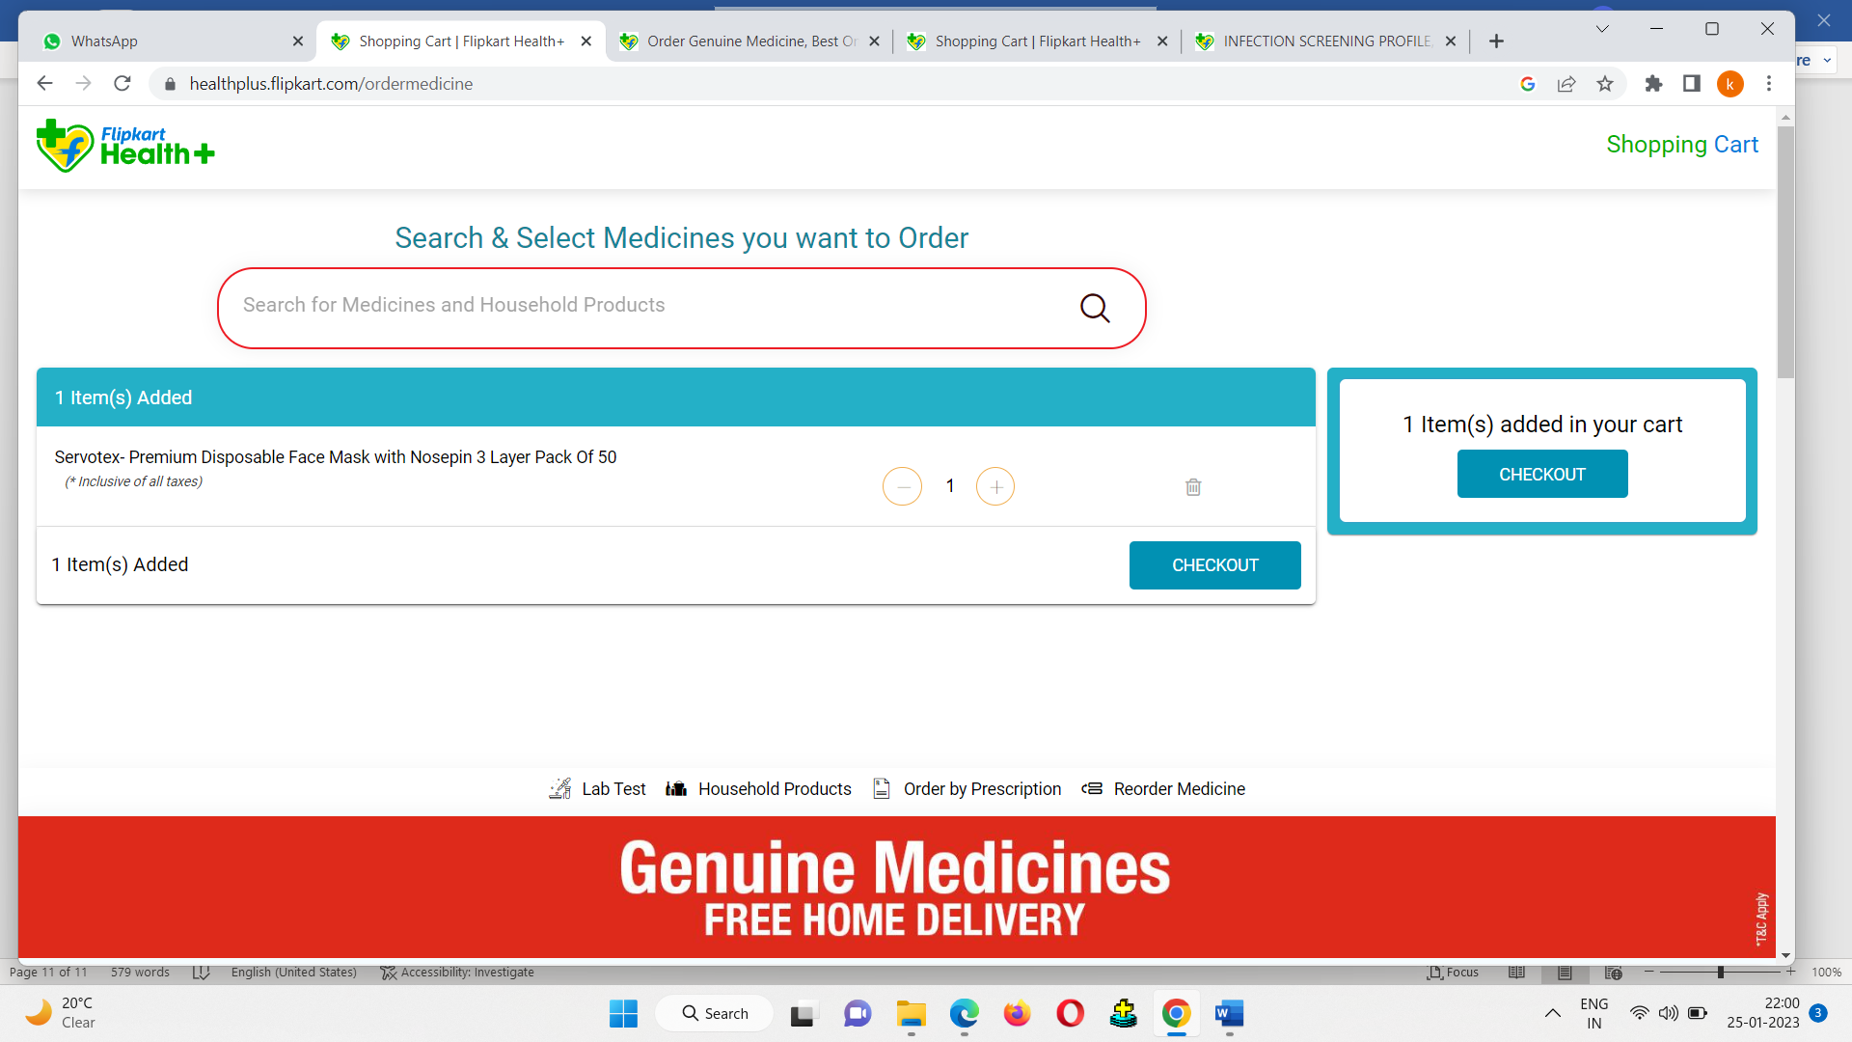

DEFECT ID  **: 008**

TEST ENVIRONMENT **:** OS (WINDOWS 11)

BROWSER (I.E.)

VERSION OF BROWSER (10)

DEFECT DESCRIPTION: OFFER PAGE LINK NOT WORKING IN IE (10)

DETAILED DESCRIPTION **:**

1. Open the browser enter the URL( [www.sastasundar.com](http://www.sastasundar.com) ), click on go button.
2. Home page of sastasundar app will be displayed.
3. Click on the offer icon.

EXPECTED RESULT **:** OFFER PAGE SHOULD BE DISPLAYED.

ACTUAL RESULT **:** OFFER PAGE IS EMPTY.

SCREEN SHOT:

1.INTERNET EXPLORER:

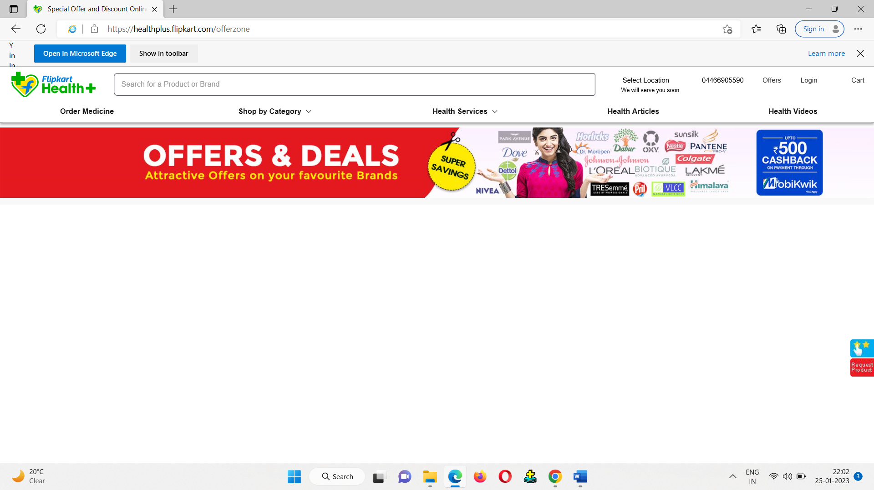

2.CHORME:

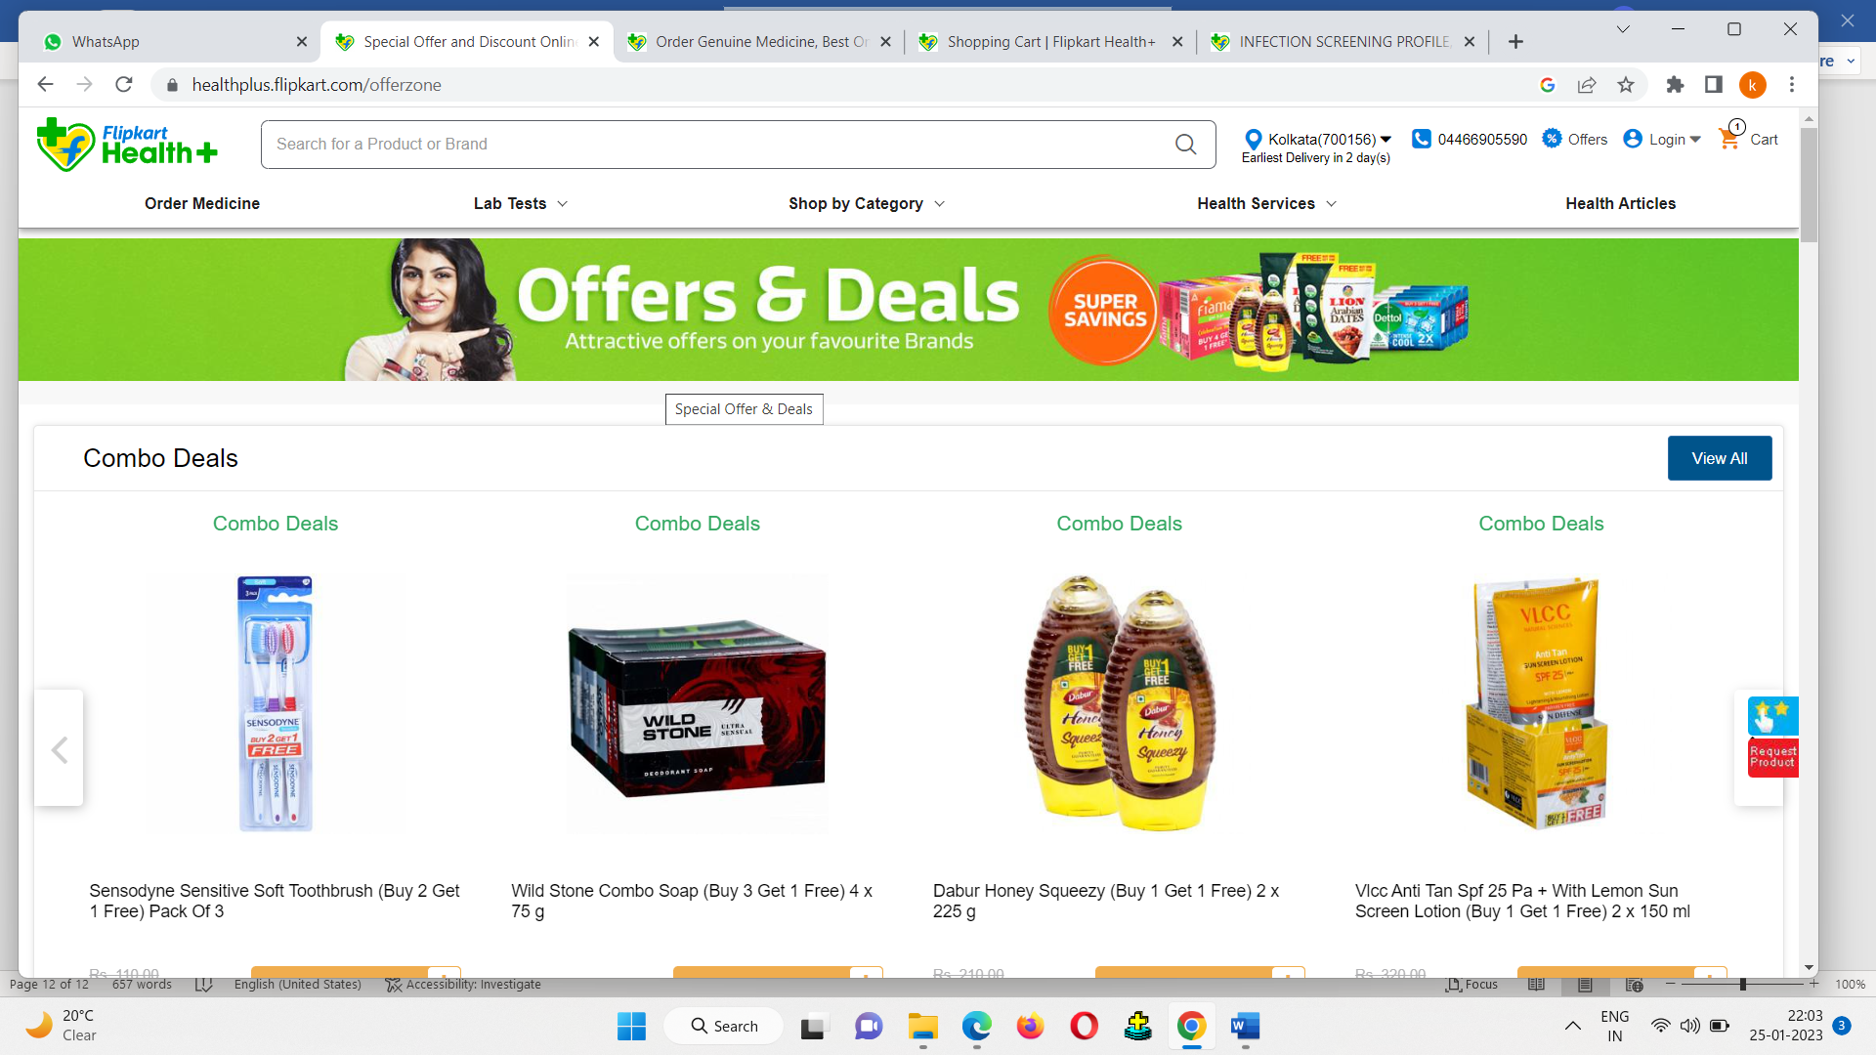

DEFECT ID  **: 009**

TEST ENVIRONMENT **:** OS (WINDOWS 11)

BROWSER (I.E.)

VERSION OF BROWSER (10)

DEFECT DESCRIPTION: SCROLL TOP BUTTONIS NOT DISPLAY IN IE (10)

DETAILED DESCRIPTION **:**

1. Open the browser enter the URL( [www.sastasundar.com](http://www.sastasundar.com) ), click on go button.
2. Home page of sastasundar app will be displayed.
3. Scroll down more than 1 page.
4. Scroll top button should be displayed

EXPECTED RESULT **:** SCROLL TOP BUTTON SHOULD BE DISPLAYED.

ACTUAL RESULT **:** SCROLL TOP BUTTON IS NOT DISPLAYED.

SCREEN SHOT:

1.INTERNET EXPLORER:

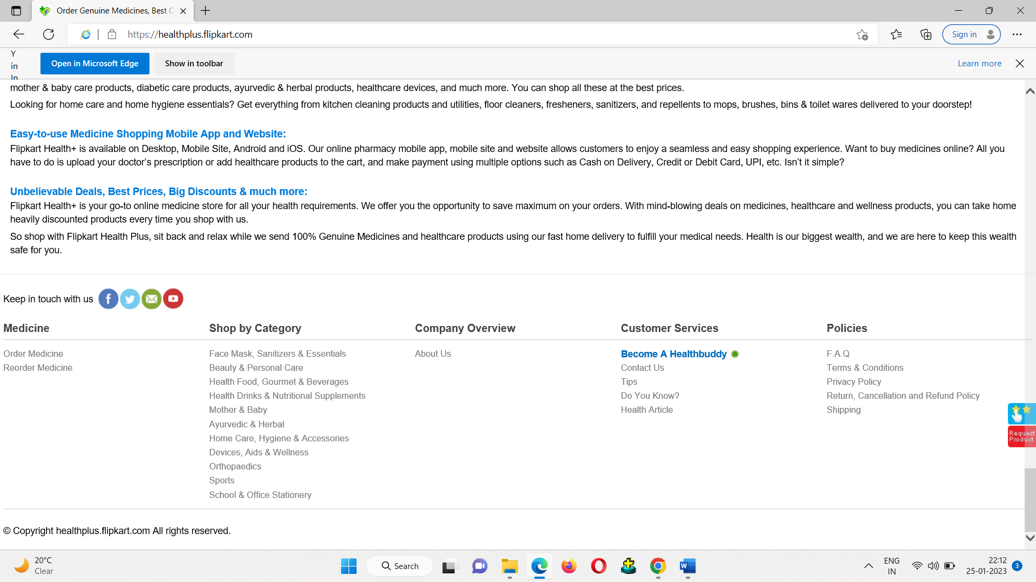

2.CHROME:

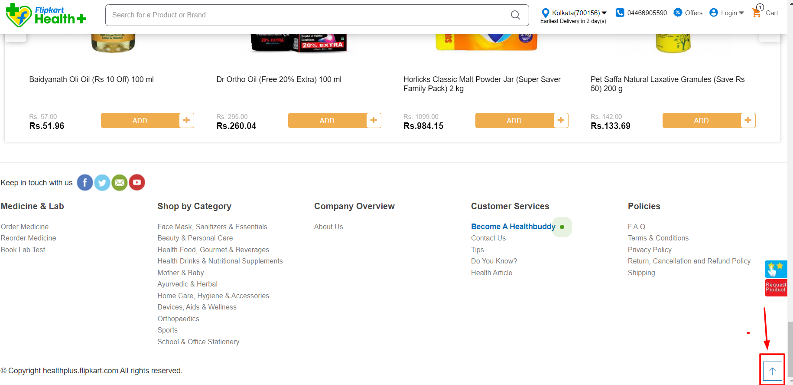

DEFECT ID  **: 010**

TEST ENVIRONMENT **:** OS (WINDOWS 11)

BROWSER (I.E.)

VERSION OF BROWSER (10)

DEFECT DESCRIPTION: PLACE CURSOR ON LOGO LINK POINTER CURSOR IS NOT VISIBLE IN IE(10).

DETAILED DESCRIPTION **:**

1. Open the browser enter the URL( [www.sastasundar.com](http://www.sastasundar.com) ), click on go button.
2. Home page of sastasundar app will be displayed.
3. Place the cursor on logo.

EXPECTED RESULT **:** LINK POINTER CURSOR SHOULD BE DISPLAYED.

ACTUAL RESULT **:** LINK POINTER CURSOR IS NOT DISPLAYED.

SCREEN SHOT:

1.INTERNET EXPLORER:

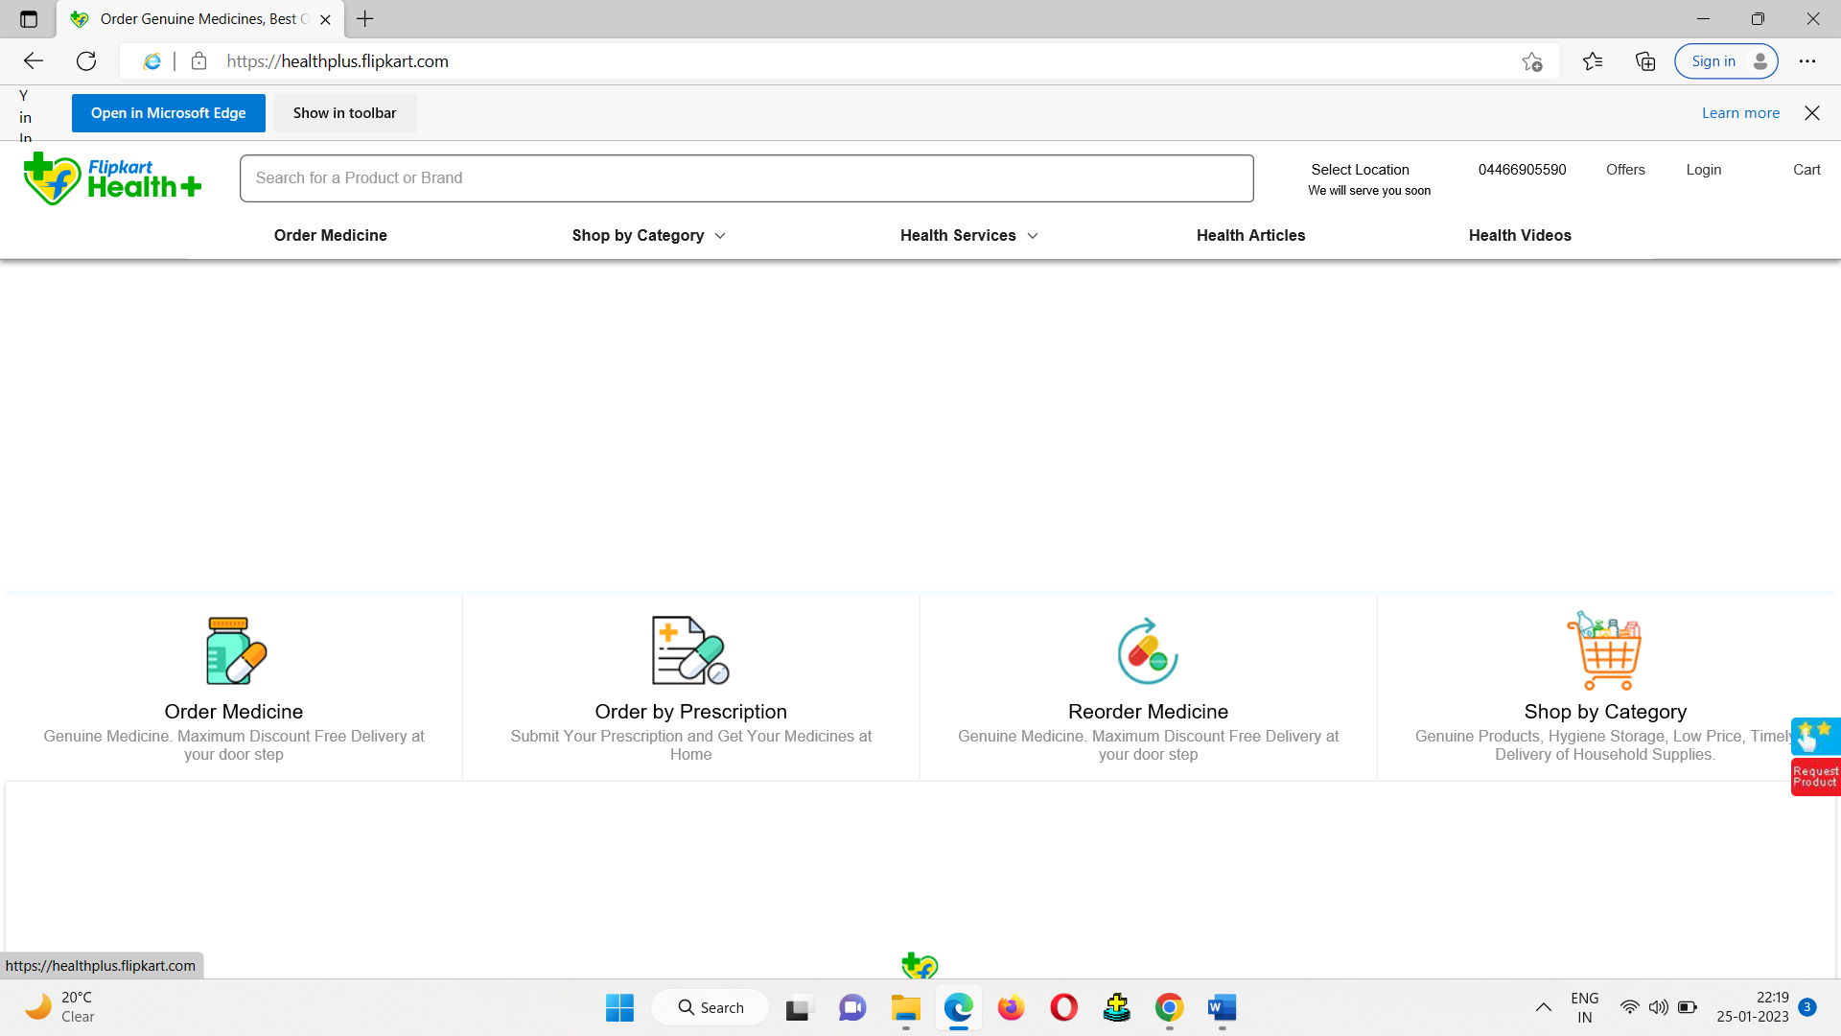

2.CHROME:

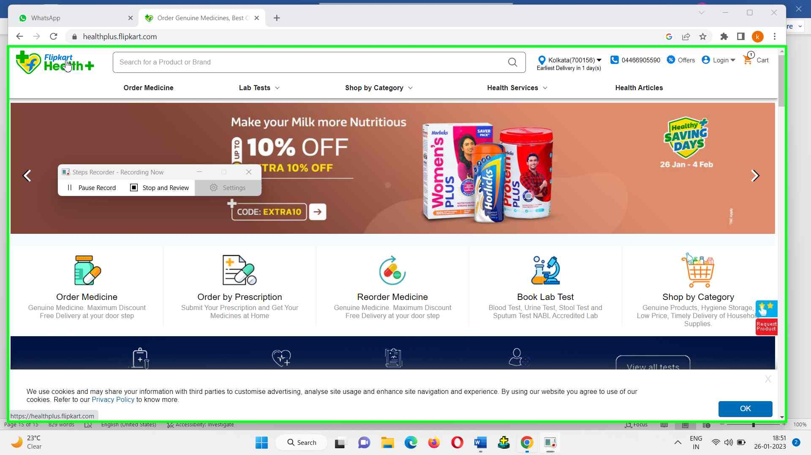

DEFECT ID  **: 011**

TEST ENVIRONMENT **:** OS (WINDOWS 11)

BROWSER (I.E.)

VERSION OF BROWSER (10)

DEFECT DESCRIPTION: LAB TEST AND ITS DROPDOWN LIST IS NOT VISIBLE IN IE(10).

DETAILED DESCRIPTION **:**

1. Open the browser enter the URL( [www.sastasundar.com](http://www.sastasundar.com) ), click on go button.
2. Home page of sastasundar app will be displayed.
3. Lab test and Lab test dropdown is not visible.

EXPECTED RESULT **:** LAB TEST AND ITS DROPDOWN SHOULD BE DISPLAYED.

ACTUAL RESULT **:** LAB TEST AND ITS DROPDOWN IS NOT

DISPALYED.

SCREEN SHOT:

1. INTERNET EXPLORER:

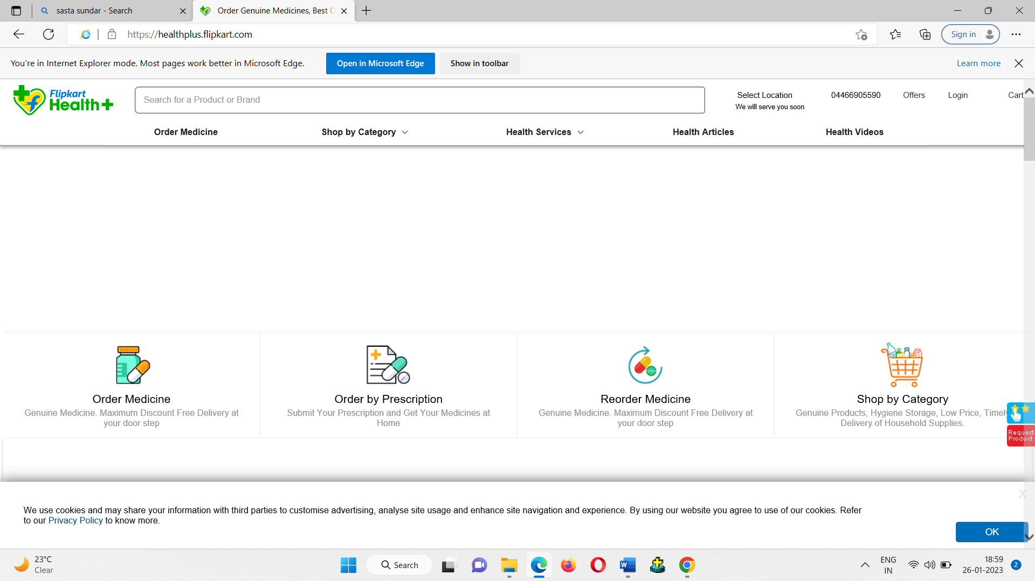

2.CHORME:

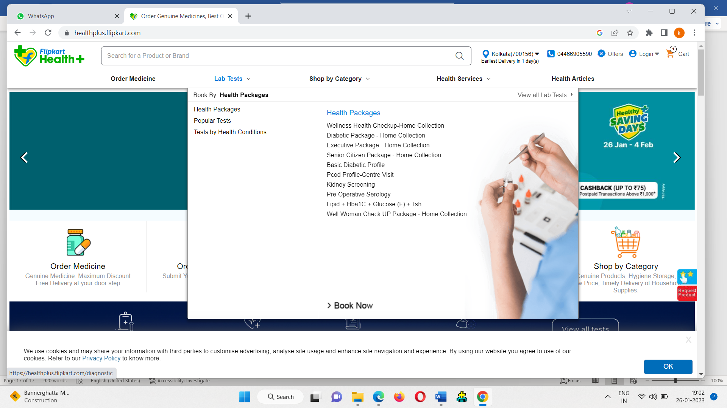

DEFECT ID  **: 012**

TEST ENVIRONMENT **:** OS (WINDOWS 11)

BROWSER (I.E.)

VERSION OF BROWSER (10)

DEFECT DESCRIPTION: SLIDESHOW IS NOT DISPLAYED IN IE(10).

DETAILED DESCRIPTION **:**

1. Open the browser enter the URL( [www.sastasundar.com](http://www.sastasundar.com) ), click on go button.
2. Home page of sastasundar app will be displayed.
3. Slideshow of the products show be displayed

EXPECTED RESULT **:** SLIDESHOW OF PRODUCTS SHOULD BE DISPLAYED.

ACTUAL RESULT **:** SLIDESHOW OF PRODUCTS IS NOT DISPALYED.

SCREEN SHOT:

1.INTERNET EXPLORER:

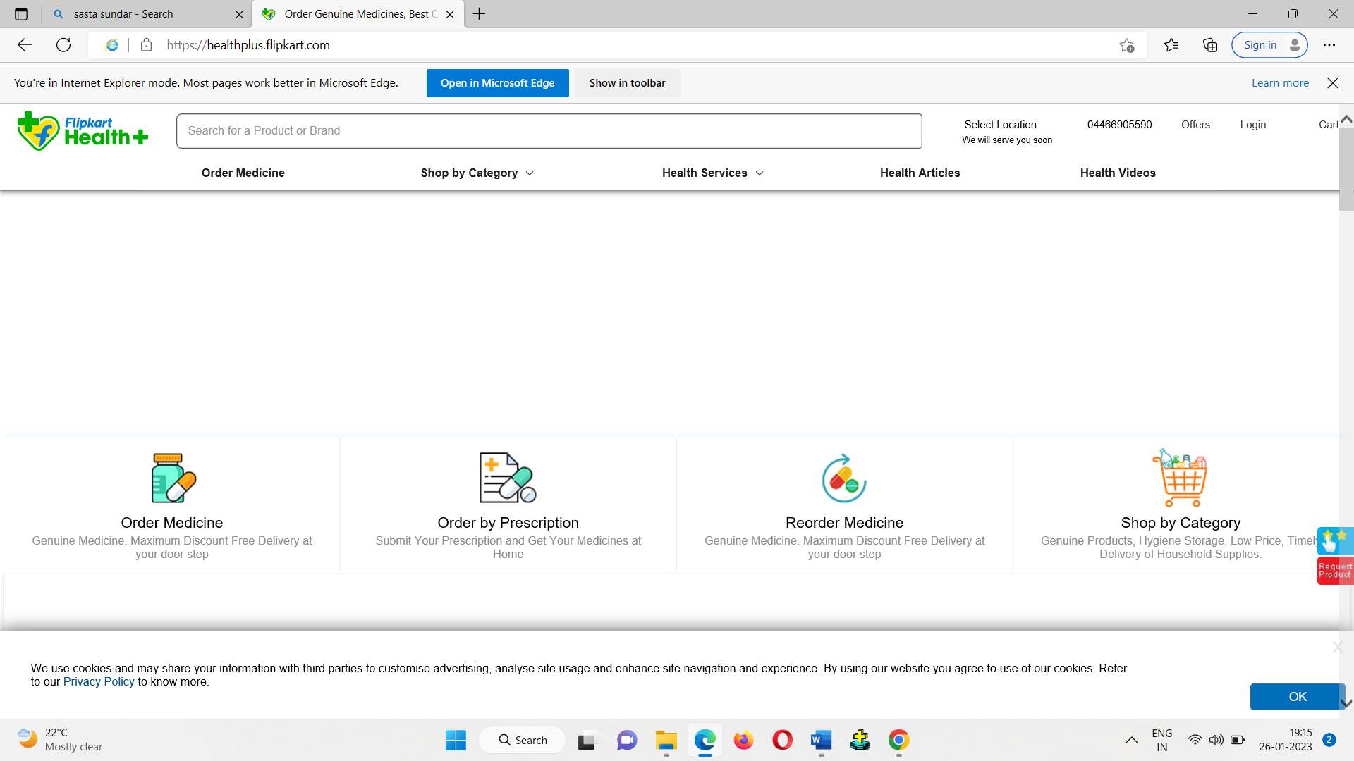

2.CHORME:

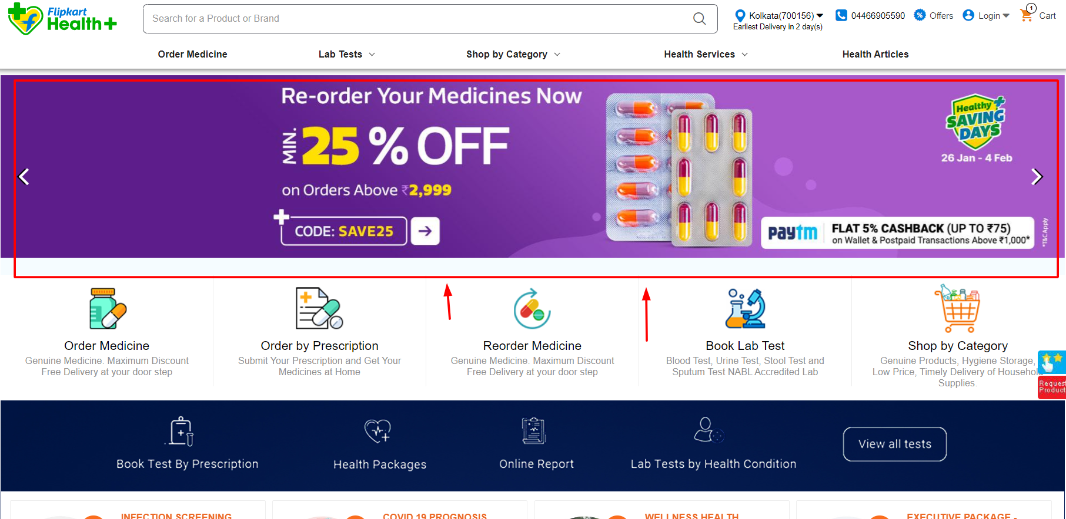

DEFECT ID  **: 013**

TEST ENVIRONMENT **:** OS (WINDOWS 11)

BROWSER (I.E.)

VERSION OF BROWSER (10)

DEFECT DESCRIPTION: MY PROFILE PAGE GETTING ERROR IN IE(10).

DETAILED DESCRIPTION **:**

1. Open the browser enter the URL( [www.sastasundar.com](http://www.sastasundar.com) ), click on go button.
2. Home page of sastasundar app will be displayed.
3. Login with valid user name and password.
4. Click on ME🡪MY PROFILE.

EXPECTED RESULT **:** MY PROFILE PAGE SHOULD SHOW WITHOUT ERROR.

ACTUAL RESULT **:** MY PROFILE PAGE SHOWING ERROR IN ALL

FIELDS.

SCREEN SHOT:

1.INTERNET EXPLORER:

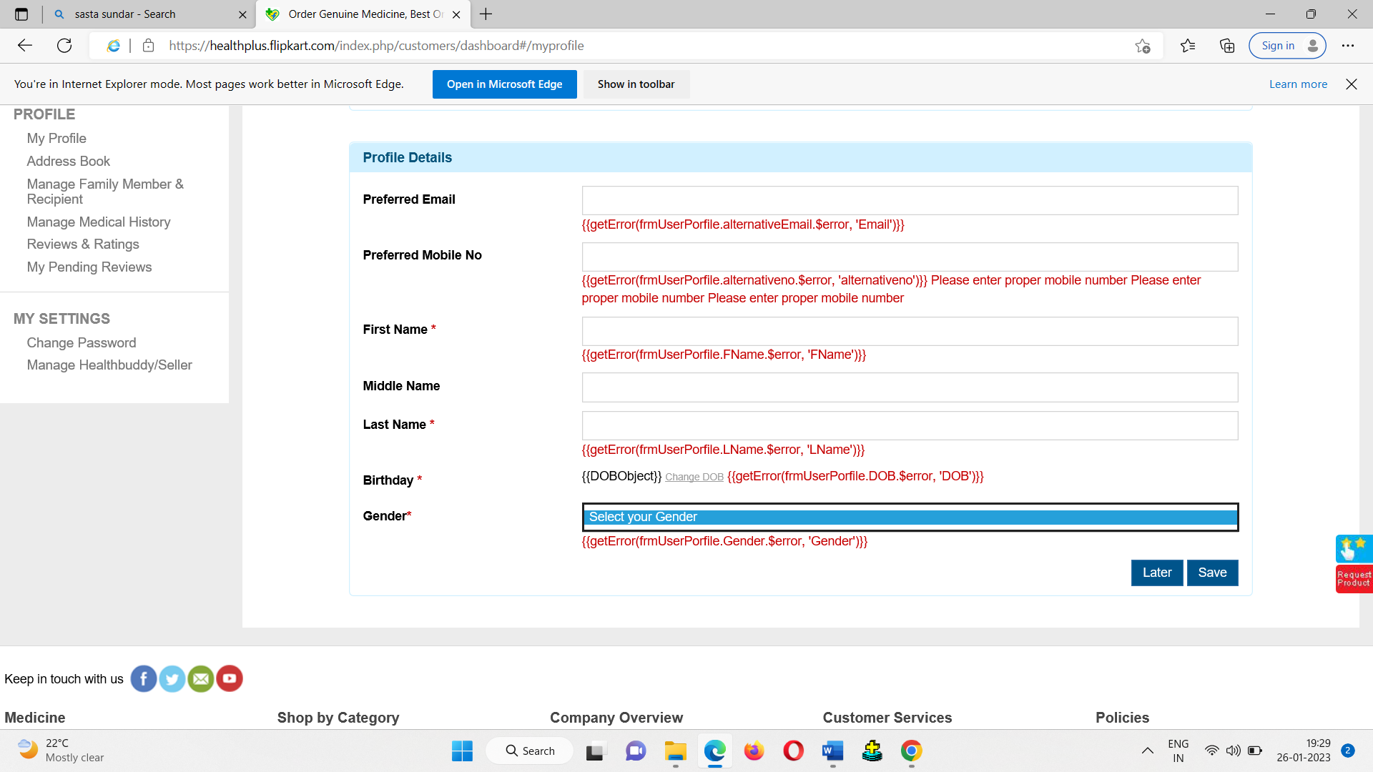

2.CHORME:

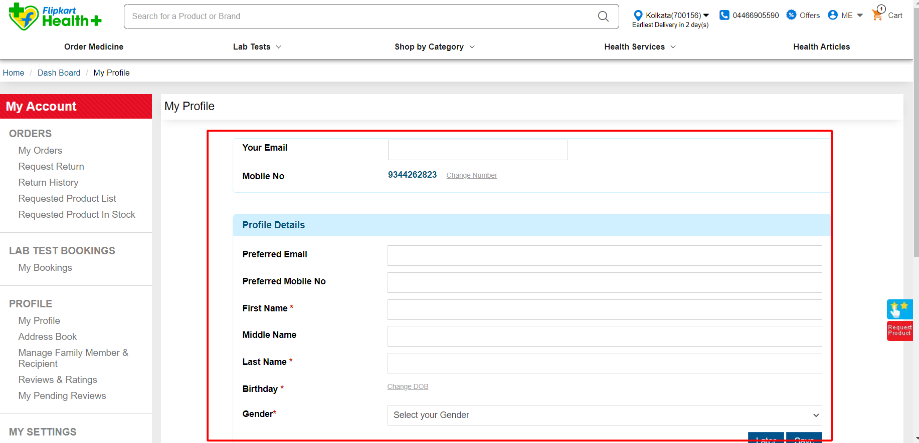

DEFECT ID  **: 014**

TEST ENVIRONMENT **:** OS (WINDOWS 11)

BROWSER (I.E.)

VERSION OF BROWSER (10)

DEFECT DESCRIPTION: RECOMMENDED PRODUCTS NOT DISPLAYED IN IE(10).

DETAILED DESCRIPTION **:**

1. Open the browser enter the URL( [www.sastasundar.com](http://www.sastasundar.com) ), click on go button.
2. Home page of sastasundar app will be displayed.
3. Scroll down in home page.

EXPECTED RESULT **:**RECOMMENDED PRODUCTS SHOULD BE DISPLAYED

ACTUAL RESULT **:** RECOMMENDED PRODUCTS IS NOT DISPLAYED

SCREEN SHOT:

1.INTERNET EXPLORER:

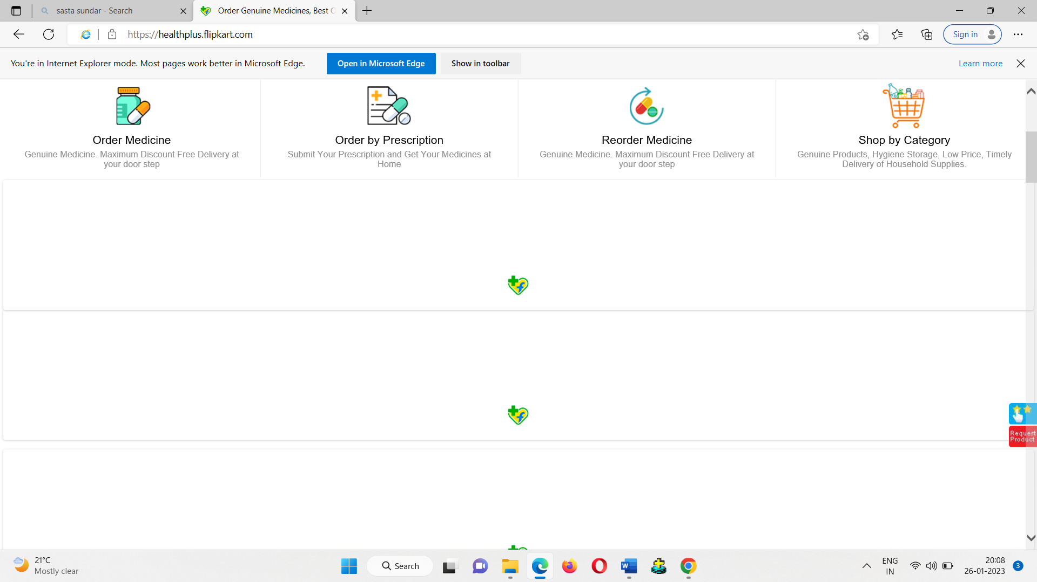

2.CHORME:

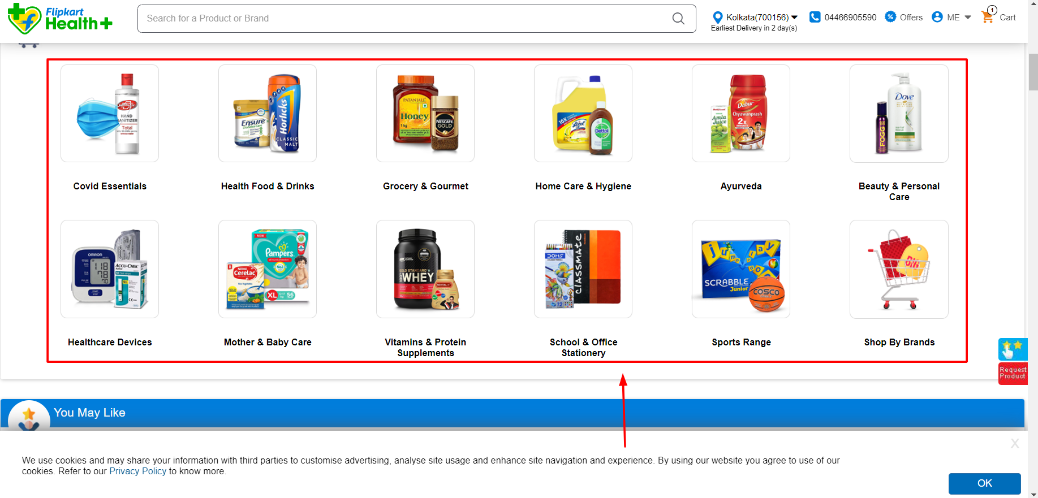

DEFECT ID  **: 015**

TEST ENVIRONMENT **:** OS (WINDOWS 11)

BROWSER (I.E.)

VERSION OF BROWSER (10)

DEFECT DESCRIPTION: VIEW ALL TESTS IS NOT DISPLAYED IN IE(10).

DETAILED DESCRIPTION **:**

1. Open the browser enter the URL( [www.sastasundar.com](http://www.sastasundar.com) ), click on go button.
2. Home page of sastasundar app will be displayed.
3. Scroll down in home page.

EXPECTED RESULT **:** VIEW ALL TESTS SHOULD BE DISPLAYED.

ACTUAL RESULT **:** VIEW ALL TESTS SESSION IS NOT DISPLAYED.

SCREEN SHOT:

1.INTERNET EXPLORER:

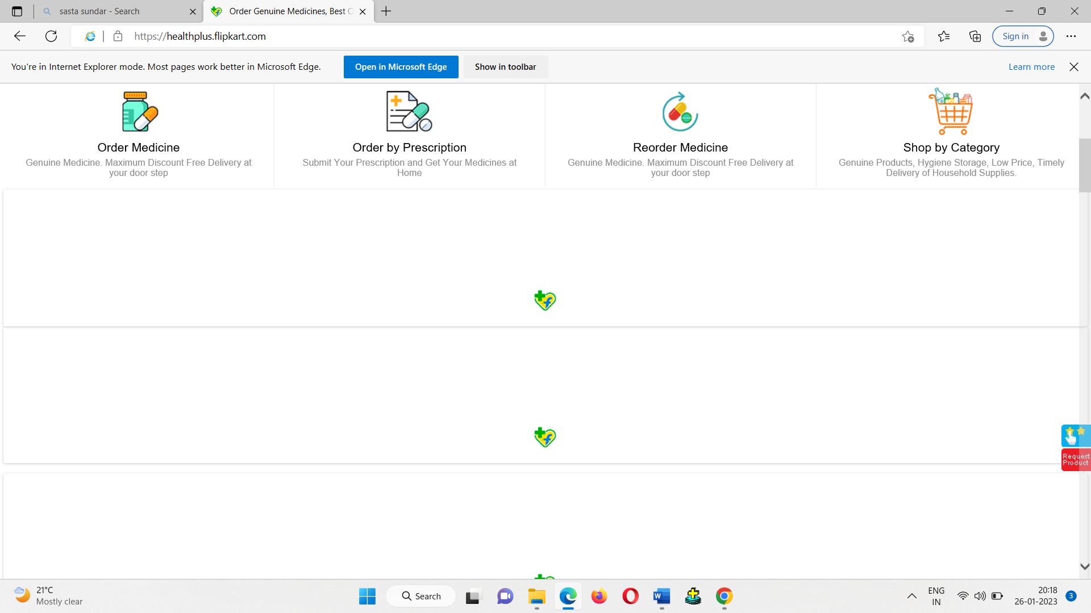

2.CHORME:

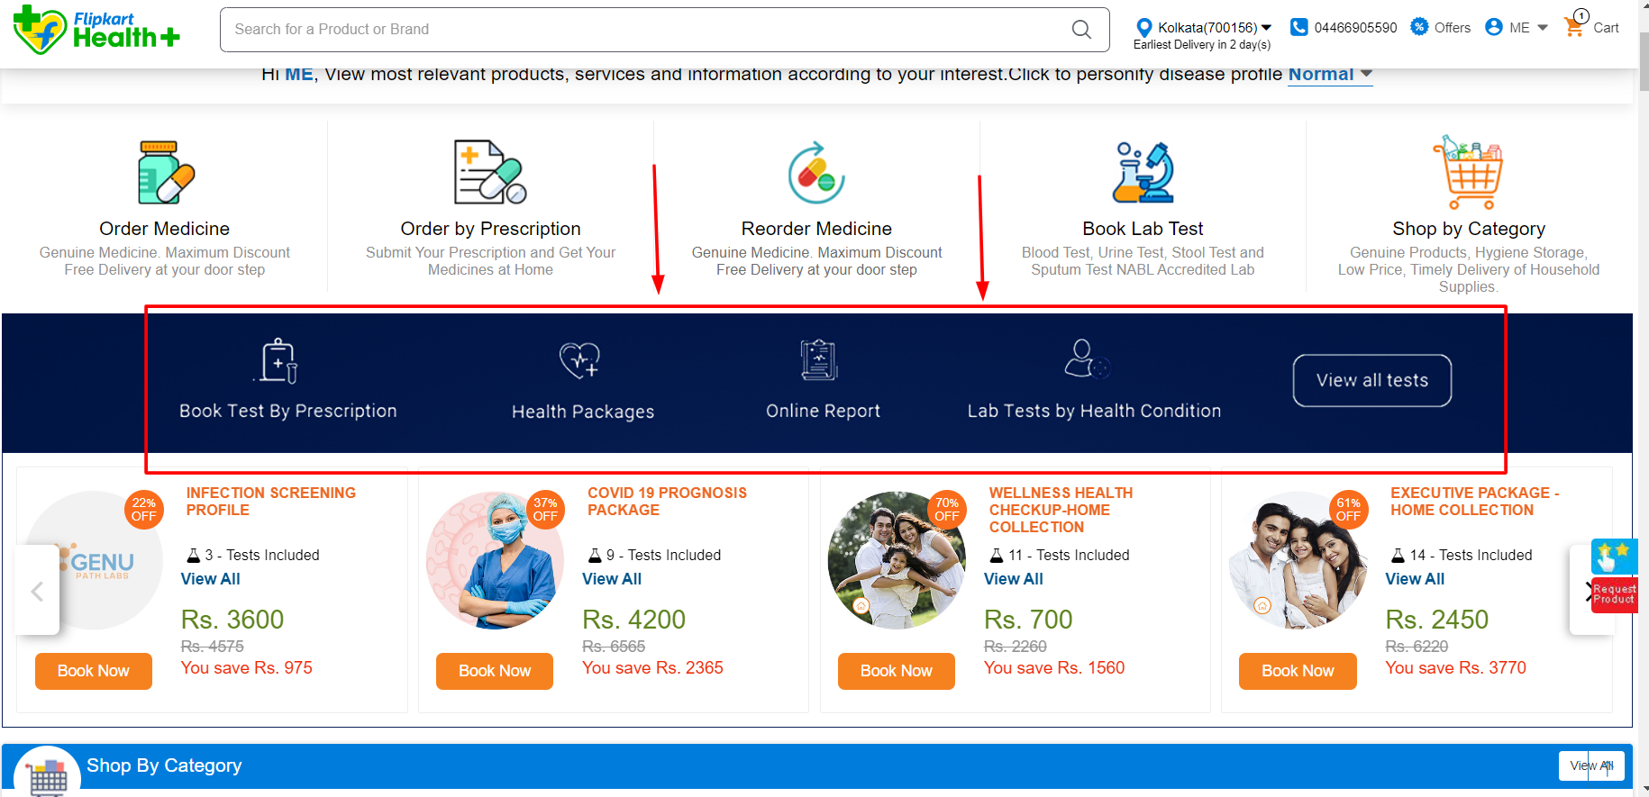

DEFECT ID  **: 016**

TEST ENVIRONMENT **:** OS (WINDOWS 11)

BROWSER (I.E.)

VERSION OF BROWSER (10)

DEFECT DESCRIPTION: SLIDESHOW OF DISCOUNTED PRODUCTS IS NOT DISPLAYED IN IE(10).

DETAILED DESCRIPTION **:**

1. Open the browser enter the URL( [www.sastasundar.com](http://www.sastasundar.com) ), click on go button.
2. Home page of sastasundar app will be displayed.
3. Slideshow of the products show be displayed

EXPECTED RESULT **:** SLIDESHOW OF OFFER PRODUCTS SHOULD BE DISPLAYED.

ACTUAL RESULT **:** SLIDESHOW OF OFFER PRODUCTS IS NOT

DISPLAYED.

SCREEN SHOT:

1.INTERNET EXPLORER:

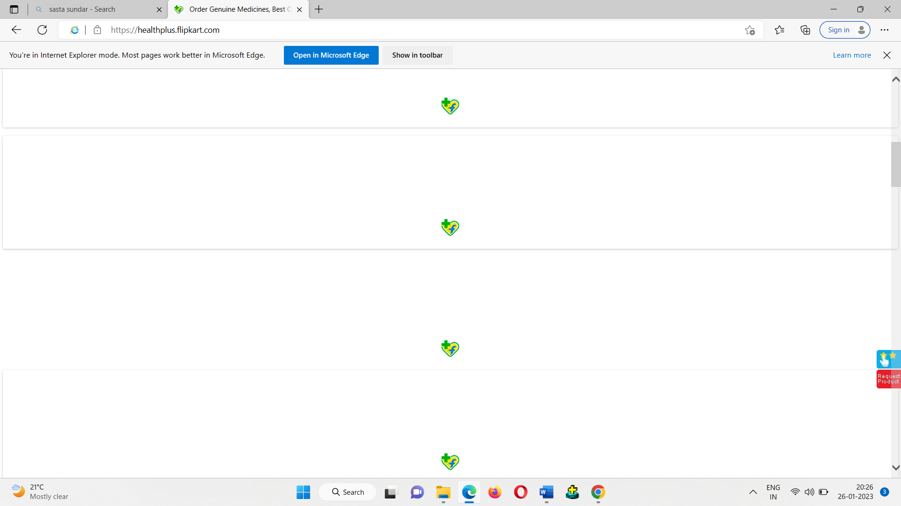

2.CHORME:

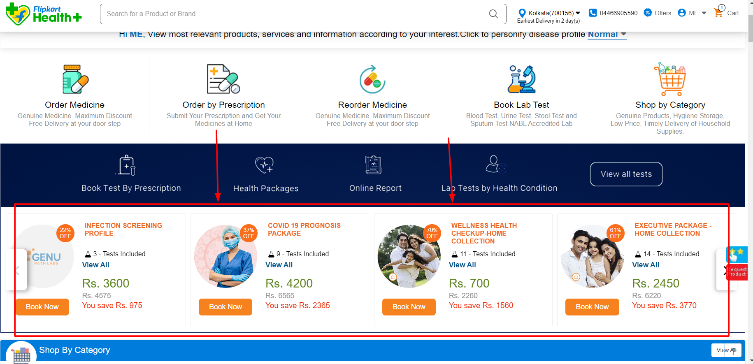

DEFECT ID  **: 017**

TEST ENVIRONMENT **:** OS (WINDOWS 11)

BROWSER (I.E.)

VERSION OF BROWSER (10)

DEFECT DESCRIPTION: COMBO DEALS PRODUCTS NOT DISPLAYED IN IE(10).

DETAILED DESCRIPTION **:**

1. Open the browser enter the URL( [www.sastasundar.com](http://www.sastasundar.com) ), click on go button.
2. Home page of sastasundar app will be displayed.
3. Scroll down in home page.

EXPECTED RESULT **:** COMBO DEALS PRODUCTS SHOULD BE DISPLAYED

ACTUAL RESULT **:** COMBO DEALS PRODUCTS IS NOT DISPLAYED

SCREEN SHOT:

1.INTERNET EXPLORER:



2.CHORME:

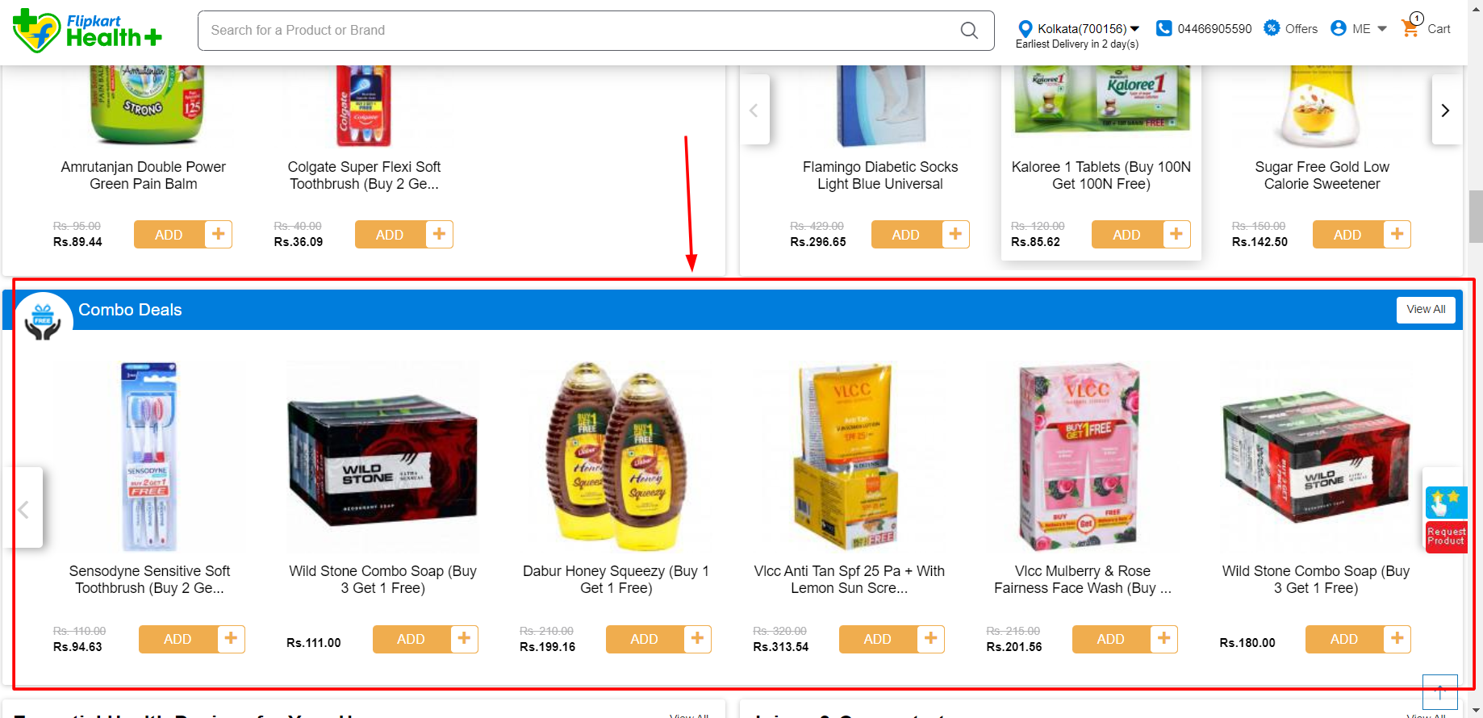

DEFECT ID  **: 018**

TEST ENVIRONMENT **:** OS (WINDOWS 11)

BROWSER (I.E.)

VERSION OF BROWSER (10)

DEFECT DESCRIPTION: PERSONAL HYGIENE CARE PRODUCTS NOT DISPLAYED IN IE(10).

DETAILED DESCRIPTION **:**

1. Open the browser enter the URL( [www.sastasundar.com](http://www.sastasundar.com) ), click on go button.
2. Home page of sastasundar app will be displayed.
3. Scroll down in home page.

EXPECTED RESULT **:** PERSONAL HYGIENE CARE PRODUCTS SHOULD BE DISPLAYED.

ACTUAL RESULT **:** PERSONAL HYGIENE CARE PRODUCTS IS NOT

DISPLAYED.

SCREEN SHOT:

1.INTERNET EXPLORER:

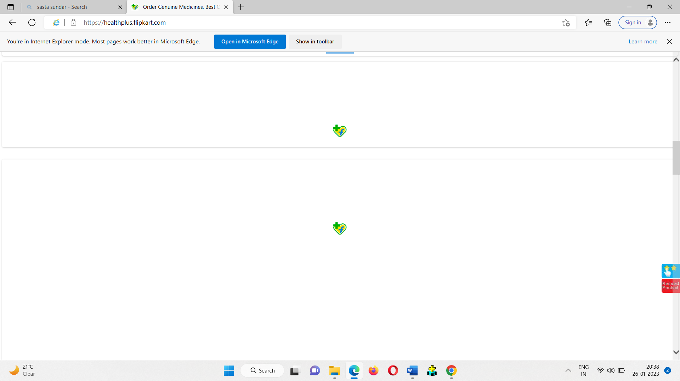

2.CHORME:

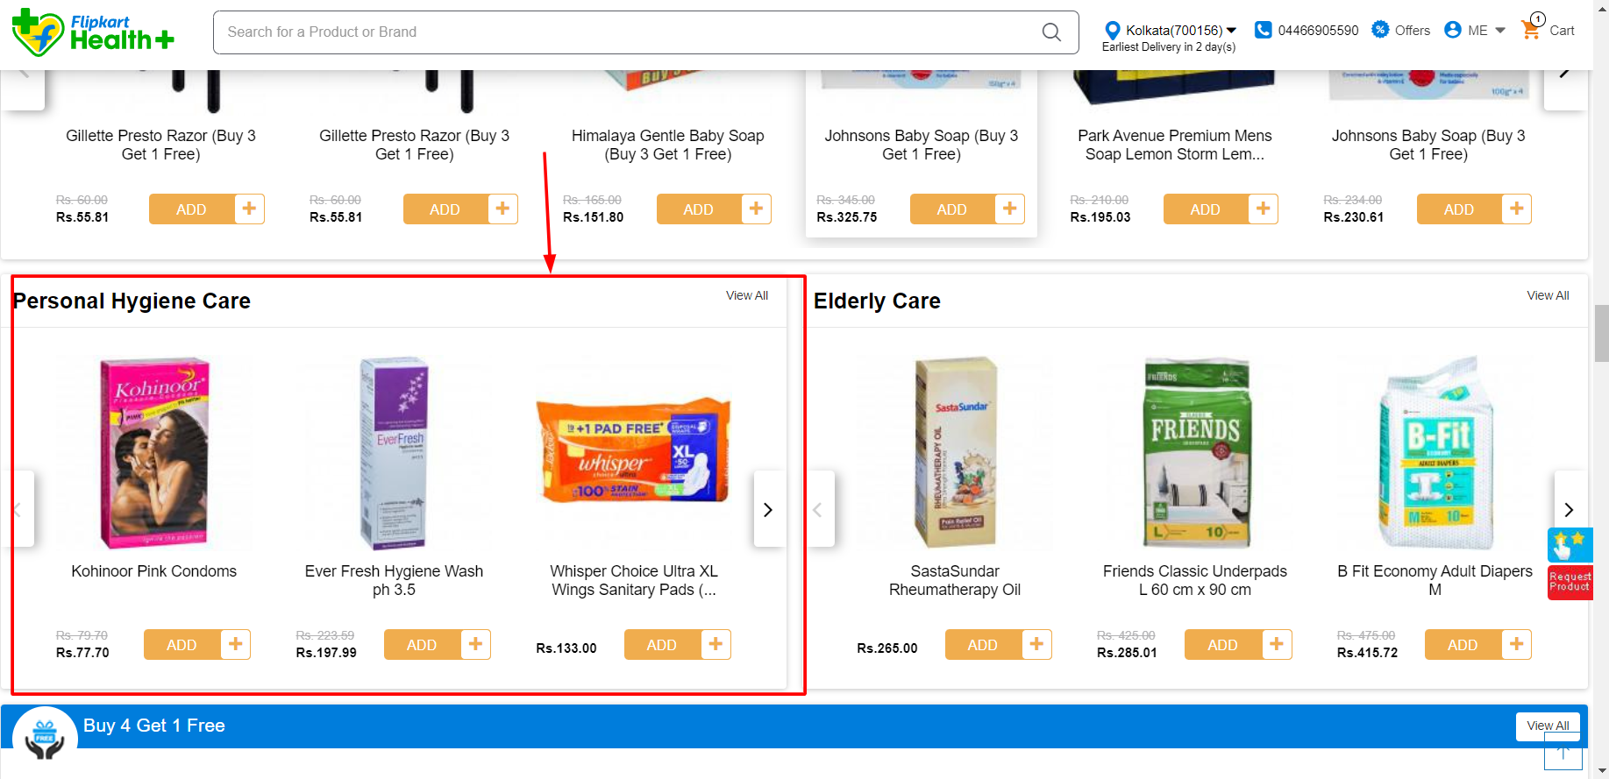

DEFECT ID  **: 019**

TEST ENVIRONMENT **:** OS (WINDOWS 11)

BROWSER (I.E.)

VERSION OF BROWSER (10)

DEFECT DESCRIPTION: PERSONAL HYGIENE CARE PRODUCTS NOT DISPLAYED IN IE(10).

DETAILED DESCRIPTION **:**

1. Open the browser enter the URL( [www.sastasundar.com](http://www.sastasundar.com) ), click on go button.
2. Home page of sastasundar app will be displayed.
3. Click on shop by category🡪facemask sanitizer & essentials🡪facemask and shields.

EXPECTED RESULT **:** FACEMASK PRODUCTS SHOULD BE DISPLAYED.

ACTUAL RESULT **:** FACEMASK PRODUCTS IS NOT DISPLAYED.

SCREEN SHOT:

1.INTERNET EXPLORER:

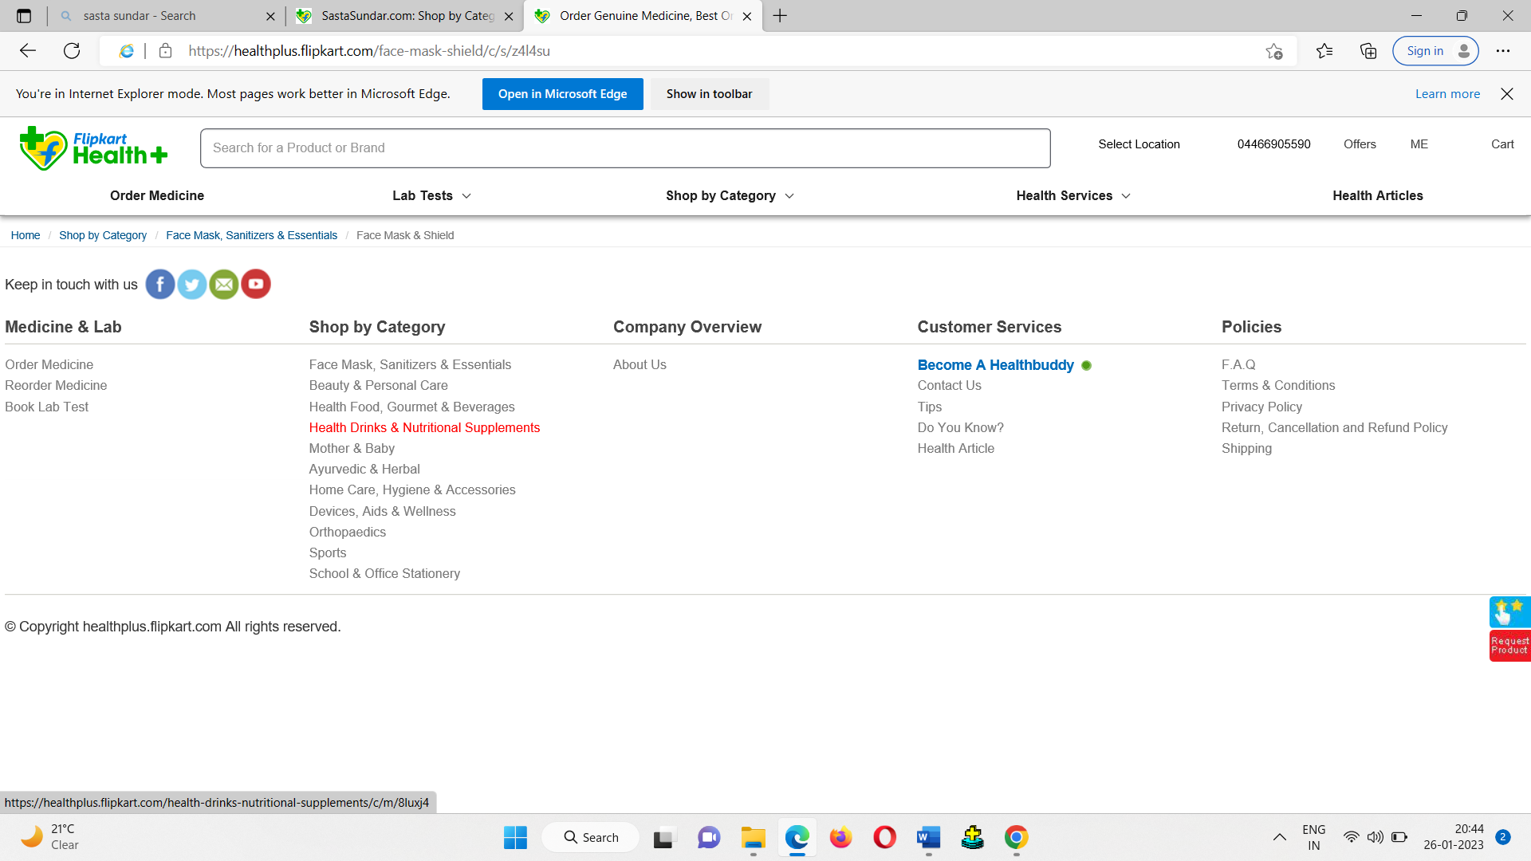

2.CHORME:

